AOLME PROJECT - LEVEL 1- SESSION 4- 2019

**AOLME Project**

**Session 4**

**Your Name: __________________________ Your partner’s name: ______________**

**4.2. Activity: Coordinates in black & white images.**

**TASK 1:** Create a figure by filling in complete squares with black.

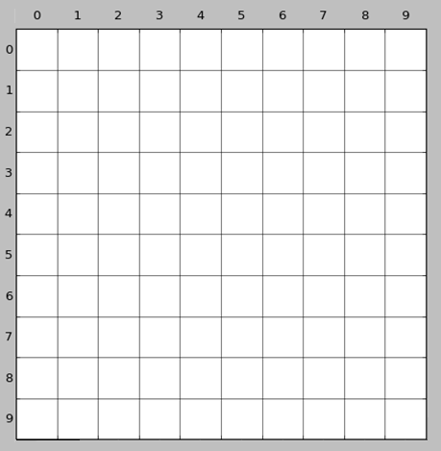

AOLME PROJECT - LEVEL 1- SESSION 4- 2019

***TASK 3:*** *In the 10x10 grid below, fill in the information that your partner tells you. Pay close attention to the code given, so you can reproduce the image the best you can. After you are done, compare your image with your partner’s. Then, switch roles.*

